**MINEX SUMMARY**

**Model 30-29-200-B 5C4 Chassis, Borosilicate Glass, Low Vibration Cryo Mount,**

**Capacitor Board and Beryllium Copper Links**

**Vacuum Very Good Auto start & continues running, Turbo 90k/8w (data recorded)**

**Cryo Very Good ColdHd 65K-LNA 68K, around 196watts (data recorded)**

**X-pole Very Good Noise (4.5 - 4.0dB out to 14GHz)**

**Y-pole Very Good Noise (5.0 - 4.0dB out to 14GHz)**

**LNA RECOMMENDED BIAS SETTINGS**

**Vm + Vd must be set exactly to values below**

**Adjust Vg as needed to get Id 24.4 to 24.8**

|  |  |  |  |
| --- | --- | --- | --- |
| **Pole** | **Minex LNA S.N.** | **Bias Settings** | **PAM’s (HC default)** |
| **X** | **C-0021a** | **Vm -.50v / Vg .19 v / Vd 1.20v / Id 24.8ma** | **15.0 / 15.0** |
| **Y** | **C-0019a** | **Vm -.50v / Vg .29v / Vd 1.20v / Id 24.7ma** |

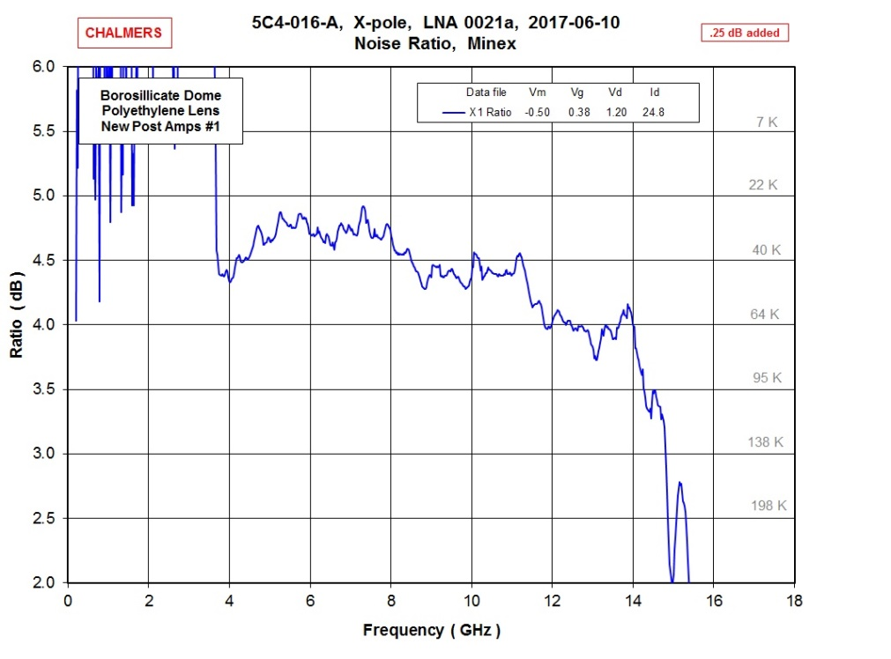

**3.4”**

